1. Draw the logic diagram of the following gates using logsim and complete the

Truth tables.

1. AND

Answer:

|  |  |  |
| --- | --- | --- |
| **A** | **B** | **A.B** |
| **0** | **0** | **0** |
| **0** | **1** | **0** |
| **1** | **0** | **0** |
| **1** | **1** | **1** |

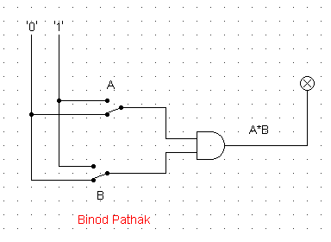

1. NOR

Answer:

|  |  |  |
| --- | --- | --- |
| **A** | **B** | **A.B** |
| **0** | **0** | **1** |
| **0** | **1** | **0** |
| **1** | **0** | **0** |
| **1** | **1** | **0** |

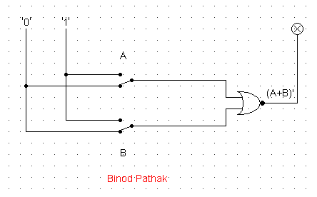

1. OR

Answer:

|  |  |  |
| --- | --- | --- |
| **A** | **B** | **A.B** |
| **0** | **0** | **0** |
| **0** | **1** | **1** |
| **1** | **0** | **1** |
| **1** | **1** | **1** |

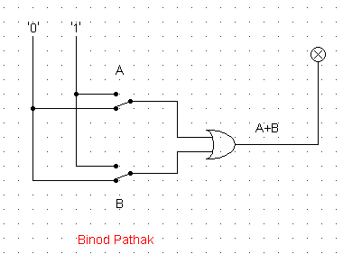

1. NAND (using NOT and AND)

Answer:

|  |  |  |
| --- | --- | --- |
| **A** | **B** | **A.B** |
| **0** | **0** | **0** |
| **0** | **1** | **1** |
| **1** | **0** | **1** |
| **1** | **1** | **1** |

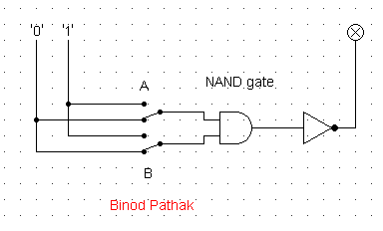

1. XOR using AOI

Answer:

|  |  |  |
| --- | --- | --- |
| **A** | **B** | **(AB’ + A’B)** |
| **0** | **0** | **0** |
| **0** | **1** | **1** |
| **1** | **0** | **1** |
| **1** | **1** | **0** |

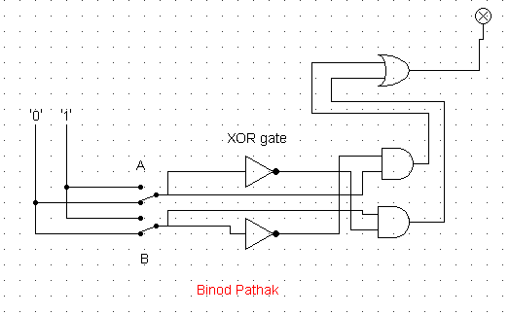

1. Use LogSim to build the equivalent circuit for the following Boolean equations.

Prove that the expressions are equivalent by computing truth table.

$$!\left(A+B\right)=!A.!B$$

Answer:

|  |  |  |  |
| --- | --- | --- | --- |
| A | B | !(A+B) | !A . !B |
| 0 | 0 | 1 | 1 |
| 0 | 1 | 0 | 0 |
| 1 | 0 | 0 | 0 |
| 1 | 1 | 0 | 0 |

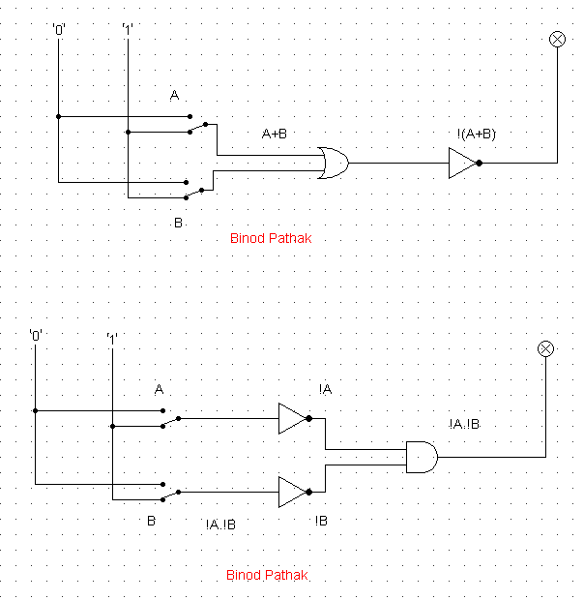

1. Draw the following circuit of half adder using LogSim.

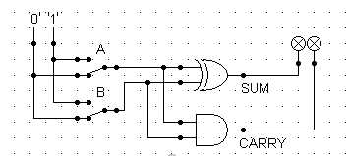

Answer:

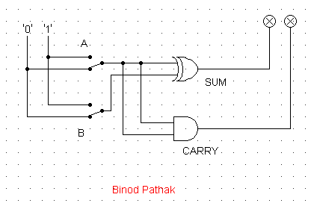

1. Draw full adder using Logsim and construct truth table.

Answer:

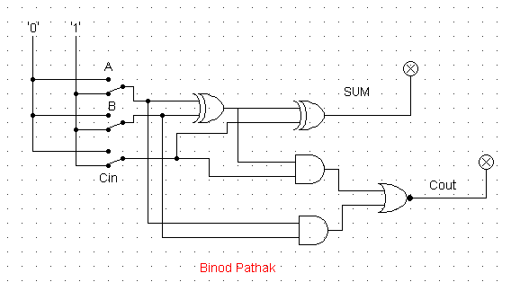

1. Draw the logic circuit for the following Boolean equations using logsim simulator.
   1. AB+C

Answer:

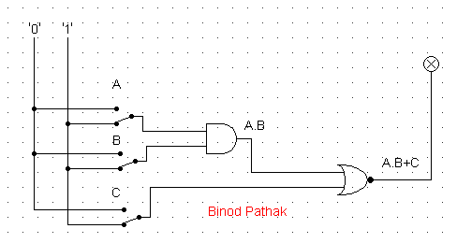

* 1. A(B+C)

Answer:

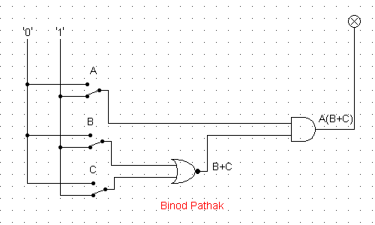

* 1. X’Y’Z’

Answer:

